Invoice and Payment Provisions
(Vendor has Not Transitioned to IPP)

The following clause is applicable to all Purchase Orders, Task or Delivery Orders, and Blanket Purchase Agreement (BPA) Calls: Prompt Payment (Jan 2017) FAR 52.232-25. Highlights of this clause and NIH implementation requirements follow:

Invoice Requirements
  - An invoice is the Contractor's bill or written request for payment under the contract for supplies delivered or services performed. A proper invoice is an "Original" which must include the items listed in subdivisions 1 through 12, below, in addition to the requirements of FAR 32.9. If the invoice does not comply with these requirements, the Contractor will be notified of the defect within 7 days after the date the designated billing office received the invoice (3 days for meat, meat food products, or fish, and 5 days for perishable agricultural commodities, dairy products, edible fats, or oils) with a statement of the reasons why it is not a proper invoice. (See exceptions under II., below.) Untimely notification will be considered in the computation of any interest penalty owed the Contractor.
    - Vendor/Contractor: Name, Address, Point of Contact for the invoice (Name, title, telephone number, e-mail and mailing address of point of contact).
    - Remit-to address (Name and complete mailing address to send payment).
    - Remittance name must match exactly with name on original order/contract. If the Remittance name differs from the Legal Business Name, then both names must appear on the invoice.
    - Invoice date.
    - Unique invoice #s for all invoices per vendor regardless of site.
    - NBS document number formats must be included for awards created in the NBS: Contract Number; Purchase Order Number; Task or Delivery Order Number and Source Award Number (e.g., Indefinite Delivery Contract number; General Services Administration number); or, BPA Call Number and BPA Parent Award Number.
    - Unique Entity Identifier (UEI) which is in the System for Award Management (SAM) and replaces the Dun & Bradstreet Data Universal Numbering System (DUNS) number.
    - Federal Taxpayer Identification Number (TIN). In those rare cases where a contractor does not have a UEI number or TIN, a Vendor Identification Number (VIN) must be referenced on the invoice. The VIN is the number that appears after the contractor’s name on the face page of the award document.
    - Identify that payment is to be made using a three-way match.
    - Description of supplies/services that match the description on the award, by line billed.*
    - Freight or delivery charge must be billed as shown on the award. If it is included in the item price do not bill it separately. If identified in the award as a separate line item, it must be billed separately.
    - Quantity, Unit of Measure, Unit Price, Extended Price of supplies delivered or services performed, as applicable, and that match the line items specified in the award.*

NOTE: If your invoice must differ from the line items on the award, please contact the Contracting Officer before submitting the invoice. A modification to the order or contract may be needed before the invoice can be submitted and paid.

Shipping costs will be reimbursed only if authorized by the Contract/Purchase Order. If authorized, shipping costs must be itemized. Where shipping costs exceed $100, the invoice must be supported by a bill of lading or a paid carrier's receipt.

NIH is using a phased transition approach from the NIH Office of Financial Management (OFM) Electronic Invoice Submission instructions to the Department of Treasury’s Invoice Processing Platform (IPP). This award will transition to IPP in the future. The Contractor shall submit invoices to the National Institutes of Health (NIH)/Office of Financial Management (OFM) via email at invoicing@nih.gov with a copy to the approving official, as directed below until the Contractor has transitioned to IPP as specified on the OALM IPP website at https://oalm.od.nih.gov/IPP. It is the vendor’s responsibility to periodically check the OALM IPP website and to be prepared to transition to IPP on the designated transition date. Questions concerning the transition to IPP should be directed to NIH-IPPinvoicing@mail.nih.gov. Questions concerning this award should be directed to the NIH Contracting Officer. All IPP invoices must contain a Unique Entity Identifier (UEI) which is located in the System for Award Management (SAM) and replaces the Dun & Bradstreet Data Universal Numbering System (DUNS) number. If this award is a parent indefinite delivery award or a Blanket Purchase Agreement Set-Up, then HHSAR 352.232-71 applies to all task/delivery orders or Blanket Purchase Agreement calls issued under this award.

The Contractor must follow step-by-step instructions as stated in the NIH/OFM Electronic Invoicing Instructions for NIH Contractors/Vendors, which is included as an attachment on the website at https://oamp.od.nih.gov/DGS/DGS-workform- information/attachment-files. The invoice shall be transmitted as an attachment via email to the address listed above in one of the following formats: Word, or Adobe Portable Document Format (PDF). The Contractor must submit only one invoice per email. Do not submit supporting documentation (e.g., receipts, time sheets, vendor invoices, etc.) with your invoice unless specified elsewhere in the contract or requested by the Contracting Officer.

The Contractor shall submit a copy of the electronic invoice to the following Approving Official (Contracting Officer) and Contracting Officer Representative:

Approving Official: Contracting Officer
Name- Email Address-

Contracting Officer Representative
Name- Email Address-

For inquiries regarding the status of invoices, contact OFM Customer Service via email at ofm_customer_service@incontactemail.com or via phone at 301-496-6088. To send your inquiries via other available communication methods refer to the OFM Customer Service website at https://ofm.od.nih.gov/Pages/Customer-Service.aspx.

Note: The OFM Customer Service is open Eastern Standard Time Monday – Friday from 8:30 a.m. to 5:00 p.m. and is closed between 12:00 p.m. to 1:00 p.m.

Invoice Payment
  - Except as indicated in paragraph B., below, the due date for making invoice payments by the designated payment office shall be the later of the following two events:

    - The 30th day after the designated billing office has received a proper invoice.
    - The 30th day after Government acceptance of supplies delivered or services performed.

  - The due date for making invoice payments for meat and meat food products, perishable agricultural commodities, dairy products, and edible fats or oils, shall be in accordance with the Prompt Payment Act, as amended.

Interest Penalties
  - An interest penalty shall be paid automatically, if payment is not made by the due date and the conditions listed below are met, if applicable.
    - A proper invoice was received by the designated billing office.
    - A receiving report or other Government documentation authorizing payment was processed and there was no disagreement over quantity, quality, or Contractor compliance with a term or condition.
    - In the case of a final invoice for any balance of funds due the Contractor for supplies delivered or services performed, the amount was not subject to further settlement actions between the Government and the Contractor.

  - Determination of interest and penalties due will be made in accordance with the provisions of the Prompt Payment Act, as amended, the Contract Disputes Act, and regulations issued by the Office of Management and Budget.

IV. PROVIDING ACCELERATED PAYMENT TO SMALL BUSINESS SUBCONTRACTORS, FAR 52.232-40 (Mar 2023).
(a)
- In accordance with 31 U.S.C. 3903 https://www.govinfo.gov/link/uscode/31/3903 and 10 U.S.C. 3801 https://www.govinfo.gov/link/uscode/10/3801 , within 15 days after receipt of accelerated payments from the Government, the Contractor shall make accelerated payments to its small business subcontractors under this contract, to the maximum extent practicable and prior to when such payment is otherwise required under the applicable contract or subcontract, after receipt of a proper invoice and all other required documentation from the small business subcontractor.
- The Contractor agrees to make such payments to its small business subcontractors without any further consideration from or fees charged to the subcontractor.
(b) The acceleration of payments under this clause does not provide any new rights under the Prompt Payment Act.
(c) Include the substance of this clause, including this paragraph (c), in all subcontracts with small business concerns, including subcontracts with small business concerns for the acquisition of commercial products or commercial services.
(End of clause).

HHSAR 352.232-71 Electronic Submission of Payment Requests (February 2, 2022).
- Definitions. As used in this clause—
Payment request means a bill, voucher, invoice, or request for contract financing payment with associated supporting documentation. The payment request must comply with the requirements identified in FAR 32.905(b), ‘‘Content of Invoices’’ and the applicable Payment clause included in this contract.

(b) Except as provided in paragraph (c) of this clause, the Contractor shall submit payment requests electronically using the Department of Treasury Invoice Processing Platform (IPP) or successor system. Information regarding IPP, including IPP Customer Support contact information, is available at www.ipp.gov or any successor site.

(c) The Contractor may submit payment requests using other than IPP only when the Contracting Officer authorizes alternate procedures in writing in accordance with HHS procedures.
(d) If alternate payment procedures are authorized, the Contractor shall include a copy of the Contracting Officer’s written authorization with each payment request.

(End of clause).

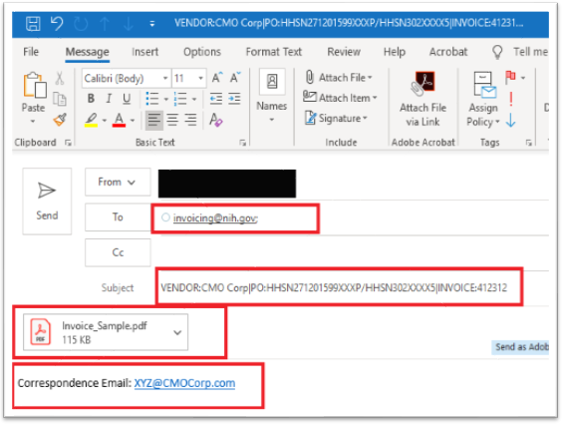
4 Steps to Create the Invoice Submission Email
Step 4:
In the body of the email, type “Correspondence
Email:” followed by your email address.
Step 3:
Attach the invoice to the email as either a PDF or Word document. See Reminders below.
Step 2:
Subject line must follow this format for the invoice you are submitting (see note* below)
Step 1:
Send invoices to the following email address:
invoicing@nih.gov

PLEASE READ THE BELOW INSTRUCTIONS THOROUGLY BEFORE SUBMITTING YOUR INVOICE ELECTRONICALLY.
*Note: The key words (Vendor, PO, and Invoice), Colon(:) character following the keywords and the PIPE (|) character must be present to identify the information. The pipe (|) character is entered by pressing and holding the shift key and the backslash (\) key at the same time. The term “PO” is being used as a generic term to identify the award number [purchase order, contract, Blanket Purchase Agreement (BPA) call, task or delivery order] and must be used in the subject line, regardless of the specific type of your award.

Page 1 of 5

How to Properly Format the Subject Line of Your Email

EXAMPLE 1 – If Your Contract Includes a Contract Number AND an Order Number or Call Number:
Vendor: Name of the Contractor or Vendor|PO:Contract Number/Order Number or Call Number|Invoice:9999999
EXAMPLE 2 – If Your Contract ONLY Includes a Contract Number:
Vendor: Name of the Contractor or Vendor|PO:Contract Number|Invoice:9999999
EXAMPLE 3 – If Your Contract ONLY Includes an Order Number:
Vendor: Name of the Contract or Vendor|Order Number|Invoice:99999999

Screenshot of How to Locate the Contract Number and Order Number on Your SF 1449
(SOLICITATION/CONTRACT/ORDER FOR COMMERCIAL ITEMS Form)
The screenshot below shows where the Contract Number and Order Number are located on the SF 1449. The SF 1449 is provided to you by the NIH Contracting Officer upon awarding the contract. Please use the information on your SF 1449 to populate the correct Contract Number and Order Number in the subject line of your email invoice submission.
The Contract Number is required to process all invoices. The Contract Number is the same as the “PO” on the invoice email subject line. The Order Number is only applicable for certain contracts and can be found in field number 4, on the SF 1449 form. If your SF 1449 does not include an Order Number, then follow EXAMPLE 2 above to ensure the Subject line of your email is properly formatted.

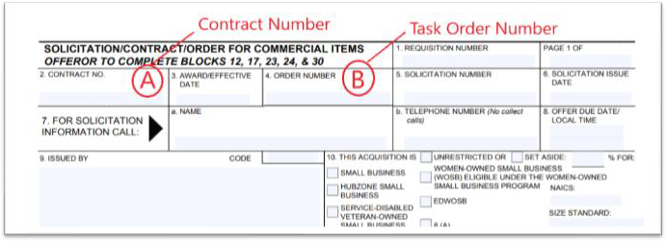

Screenshot of How to Locate the Contract Number on Your SF 1447
(SOLICITATION/CONTRACT Form)

The screenshot below shows where the Contract Number is located on the SF 1447. The SF 1447 is provided to you by the NIH Contracting Officer upon awarding the contract. Please use the information on your SF 1447 to populate the correct Contract Number in the subject line of your email invoice submission.
The Contract Number is required to process all invoices. The Contract Number is the same as the “PO” on the
invoice email subject line.
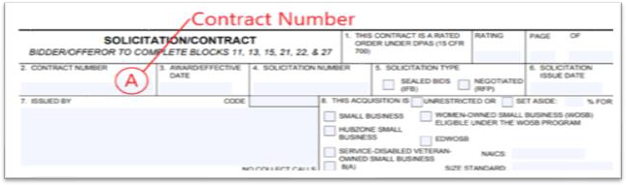

Screenshot of How to Locate the Contract Number and Release Number on Your OF 347
(ORDER FOR SUPPLIES OR SERVICES Form)
The screenshot below shows where the Contract Number and Order Number are located on the OF 347. The OF 347 is provided to you by the NIH Contracting Officer upon awarding the contract. Please use the information on your OF 347 to populate the correct Contract Number (if any) and Order Number in the subject line of your email invoice submission.
The Order Number is required to process all invoices. If there is no Contract Number, the Order number is the same as the “PO” on the invoice email subject line. The Contract Number is only applicable for certain contracts and can be found in field number 2, Contract Number, on the OF 347 form. If your OF 347 does not include a Contract Number, then follow EXAMPLE 3 on page 2 to ensure the Subject line of your email is properly formatted.

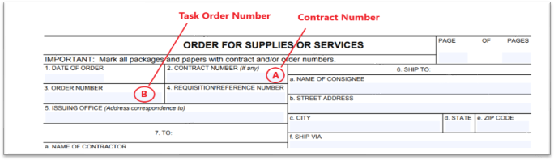

Subject Line Examples

For your reference, below is a chart listing examples of the correct and incorrect subject lines. Note: These are just examples, you must enter the applicable information for the invoice you are submitting.

Subject Line | Correct | Incorrect
Vendor: XYZ Corp|PO:HHSN299202000053J/75X98019S00848|Invoice:XYASAD
XYZ Corp|PO # HHSN299202000053J \75X98019S00848|Invoice # XYASAD
XYZ Corp| HHSN299202000053J \75X98019S00848|Invoice # XYASAD
XYZ Corp| HHSN299202000053J \75X98019S00848| XYASAD
Vendor: XYZ Corp,PO: HHSN299202000053J \75X98019S00848,Invoice:XYASAD
Vendor: XYZ Corp|PO:HHSN299202000053J|Invoice:XYASAD
Vendor: XYZ Corp|PO:HHSN311201600011U|Invoice:XYASAD

Reminders
- Effective December 1, 2020, OFM will no longer accept hard copy vendor invoices sent to the OFM billing office via any shipping services (i.e., USPS, FedEx, UPS, DHL, etc.) or those delivered by any in-person drop off. OFM will not accept any invoices postmarked and/or delivered in-person on/after December 1, 2020. Please follow the electronic submission instructions on page 1. Failure to follow the above electronic submission instructions will result in invoice processing delays.
- Only invoices should be sent to the following mailbox: invoicing@nih.gov. Please do not send emails to this mailbox requesting a status of your invoice(s) and do not include the invoicing@nih.gov email address in your correspondence with NIH Institutes/Centers.
- You must submit only one invoice per email.
- Follow the system size limits that apply to the email and each invoice: individual email attachments cannot exceed 5 megabytes each; and the email plus all attachments cannot exceed a total of 30 megabytes.
- Clearly identify a valid and complete contract number on each invoice.
- Clearly identify an accurate Unique Entity Identifier (UEI) number on each invoice.
- DO NOT include confidential information such as Social Security Numbers (do not include TIN if it is a Social Security Number).
The invoice attached to the email must be in a PDF or Word format. The date/time that a valid invoice is submitted electronically to the email box (invoicing@nih.gov) will be the same date/time logged as the invoice is received by NIH.

Questions?
Please direct inquiries regarding the status of invoices such as receipt of invoices, due date, or payment of invoices to the OFM, Customer Service Office. The OFM Customer Service contact information and of methods to contact are available at the following OFM website https://ofm.od.nih.gov/Pages/Customer-Service.aspx and below.

The Customer Service Office is open Monday – Friday from 8:30 am to 5:00 pm (Eastern Standard Time) and is closed daily between 12:00 pm to 1:00 pm (Eastern Standard Time). The Customer Service Office phone number is 301-496-6088.
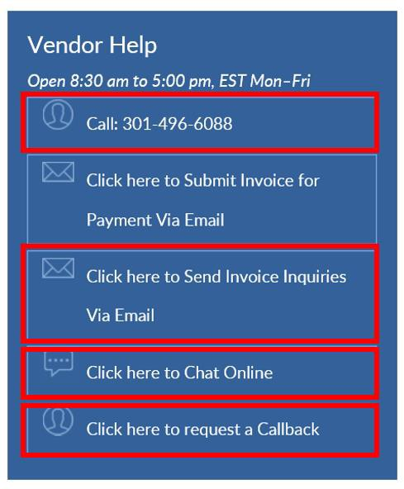
Instructions for Contractor/Vendor Courtesy Copy Electronic Invoice Submission to the Contracting Officer (CO):
The Contractor/Vendor shall send a cc: copy to the NIH Contracting Officer and the NIH Contracting Officer’s Representative (COR) stated in the award and the NIH Program point of contact when submitting the invoice to NIH/OFM for payment.

